**Machine Learning for Early Detection and Analysis of Cardiovascular Diseases using RandomForestClassifier**

**Meghana Jathan, Rakshith Vijay**

**Abstract:**cardiovasculardisease (CVD) is one of the leading causes of death worldwide and should be effective early and timely intervention and prevention mechanisms should be investigated. The project, called “Predictive Hearts,” aims to develop machine learning for early detection and diagnosis of heart disease. This model uses relevant medical information such as age, gender, blood pressure, cholesterol level, and behavior using the Python programming language and many data analysis structures. The process includes preliminary data, electronic data analysis (EDA), feature selection, and design. In addition, the performance of the model is evaluated using indicators such as accuracy, precision and memorability. Through visualization and analysis, you can understand risks and gain the ability to predict the model, helping doctors make decisions. The primary goal of the program is to provide reliable and measurable tools for the early detection of people at risk of heart disease, facilitate self-treatment, and improve patient outcomes.

**Keywords:**

**Cardiovascular diseases (CVDs), Early detection, Machine learning, Python, Data analysis, Predictive modelling, Feature selection, Healthcare, Risk factors, Precision medicine**

**Introduction:**

Cardiovascular disease (CVD) is a major global health problem and the leading cause of death worldwide. To improve public health outcomes, new strategies for early diagnosis and evaluation of cardiovascular diseases are urgently needed. Predictive Hearts is a startup that uses the power of ML to transform heart care. The program is inching closer to predictive analytics by using large amounts of patient data to create model which  can identify individuals at risk for heart disease. Early detection and detailed evaluation of CVD-related risk factors may improve treatment. Introducing technologies such as RandomForestClassifier algorithm to provide clinicians with powerful tools for effective decision making. The brand aims to open a new era in the healthcare industry by examining different demographic and clinical characteristics such as Age, Gender, BP and Cholesterol levels. Viewed through the lens of machine learning, “Predictive Hearts” promises to significantly reduce morbidity and mortality due to cardiovascular diseases, ultimately resulting in improved health and stronger health from the global population.

**Literature Review:**

Data mining and machine learning have made great strides in healthcare in recent years. This technique has become popular and proven itself in many medical fields, especially in the treatment of heart diseases. Thanks to the rapid accumulation of information in this field, scientists now have a unique opportunity to develop and evaluate new methods in medicine.

The multiple regression model developed by K. Polaraju and colleagues to predict heart disease showed that multiple regression is a suitable method for predicting heart disease risk. [1] To accomplish this task, a training dataset of 3000 patients with 13 different features described previously was used. Thirty percent of the data set is used for testing and the remaining seventy percent is used for training. The results show that the classification accuracy of the regression algorithm is better than other methods.

To identify the most important risk factors for cardiovascular disease (CVD) in patients with metabolically related fatty liver disease (MAFLD), Drod et al. (2022) [2] used machine learning (ML) methods. One hundred ninety-one patients with MAFLD were examined for blood chemistry and evaluation of subclinical atherosclerosis.

Marja et al. [3] used multilayer information using WEKA software, Bayes Net, KStar, j48, and SMO to improve cardiovascular disease prediction. In many ways, from a performance perspective, SMO and Bayesian networks outperform KStar, multilayer detection, and J48 technologies when using k-fold cross-validation. However, the performance of these algorithms is still inadequate. Therefore, the actual performance has been increased to create better diagnostic options.

S. Seema et al. [4] focused on methods of examining historical medical data, including the use of artificial neural network (ANN), decision tree, support vector machine (SVM), and naive Bayes for chronic disease prediction.

Classifiers are compared to determine which classifier performs better in terms of accuracy and speed. This test shows that SVM has the highest accuracy, while Naive Bayes has the highest accuracy for diabetic patients.

Ashok Kumar Dwivedi and his colleagues have proposed various algorithms such as Naive Bayes, Classification Trees, KNN, Logistic Regression, SVM and ANN. [5]. Logistic regression is more accurate than other algorithms.

Megha Shahi and colleagues proposed predicting heart disease using data mining technology. [6]. WEKA software is used in hospitals to provide quality service and diagnose diseases. Various algorithms were used in this study, including SVM, Naive Bayes, Association Rules, KNN, ANN and Decision Trees. The SVM proposed in the article is more accurate and efficient than other data mining methods.

The proposal of Chala Beyene et al [7] is to use data mining techniques to predict and analyze the development of cardiovascular diseases. The main goal is to quickly predict the development of heart disease and identify pain. This plan is especially useful for healthcare organizations where professionals have retired or lost their skills. It analyzes many medical factors, such as age, gender, diabetes and heart rate, to determine whether a person has heart disease. WEKA software was used to calculate data analysis.

R. Sharmila et al suggested the use of nonlinear distributions for cardiovascular disease prediction. [8]. SVM is proposed to be used with big data such as Mapreduce and Hadoop Distributed File System (HDFS) to predict heart disease by optimizing attributes. This study investigates the use of quantitative data mining in cardiovascular disease prediction. It is recommended to use HDFS to store large amounts of data on multiple nodes and run the SVM prediction algorithm on multiple nodes simultaneously. Calculation of parallel SVM is faster than sequential SVM.

Jayami Patel et al. The use of data mining and machine learning algorithms for cardiovascular disease prediction has been proposed. [9]. The aim of this study is to use data mining techniques to reveal hidden patterns. Compared with LMT, the J48 consensus algorithm based on UCI data has the highest accuracy.

Purushottam et al.'s [10] effective data-mining-based cardiac disease prediction method was proposed. This approach assists medical professionals in making wise decisions based on specific criteria. International Journal of Computer Applications (0975–8887) Volume 181–No. 18, September 2018, through the testing and training phase For a given parameter, it yields a testing phase accuracy of 86.3% and a training phase accuracy of 87.3%.

K. Gomathi and colleagues proposed a data mining technique for various disease markers. [11th]. Today, information is important only in predicting certain diseases. The number of tests can be reduced by using mining techniques. This article covers heart disease, diabetes, breast cancer, and other possible diseases.

Jinbo, Chechao etc. A model for “predicting heart failure risk using EHR sequence data” is proposed, developed using a neural network. This article uses electronic health record (EHR) data from realworld data on heart disease to test and predict heart disease earlier. We like to use singlebit encryption and word vectors to model test cases and predict failure cases, thus using key points of the continuous model. We like to demonstrate the importance of respecting the nature of medical data by analyzing the results [12]. Akash Chauhan et al. Prepare the topic “Using Evolutionary Rule Learning to Predict Heart Disease.” This research eliminates manual work and also facilitates the extraction of data (data) directly from electronic data. We used the patient data mining integrated model to create a powerful integration. This will help reduce the number of services and show that most of the rules contribute to the best prediction of heart disease.

[13]. Ashir Javed, Zhou Shijie and others. “Develop intelligent learningbased detection algorithms and optimize forest models to improve heart disease diagnosis.” This article uses random search algorithm (RSA) for feature selection and random forest models to detect heart disease. The model is generally optimized for use with grid search algorithms.

There are two types of tests used to predict heart disease. In the first experiment, a random forest model was created; In the second experiment, a random forest model was created based on the search algorithm. Compared with the random forest model, our method is simpler and more efficient. It provides a 3.3% increase in accuracy compared to traditional random forest. The educational approach may help physicians improve the accuracy of heart failure diagnosis [14].

“Processing Cardiovascular Disease Using Hybrid Machine Learning” by Senthilkumar Mohan, Chandrasegar Thirumalai, and colleagues is a great way to use hybrid machine learning. Hybrid methods combine linear methods with random forests. Data sets and feature subsets are collected for prediction. Initial information (information) about heart disease is used to choose the good ones. Mixed methods are used to diagnose heart disease after pretreatment [15].

"Rapid policybased assessment of heart disease in distributed mining" by Dr. C.R.K. Reddy and K. Prasanna Lakshmi. We use association classification mining between windows of streaming data in the proposed Stream Relational Classification of Heart Disease Prediction (SACHDP). This article is divided into two stages: First, union classification mining is used to generate the rules, and then chisquare testing is used to cut the rules and organize them into a set of rules. Using these levels, heart disease can be easily predicted [16].

The research objectives proposed by Narain et al. [17] aim to develop a revolutionary machine learningbased cardiovascular disease (CVD) prediction to improve the accuracy of the widely used Framingham Risk Score (FRS). The proposed method is to use quantum neural networks to identify and study CVD patterns.

It was validated and compared with the Framingham Study System (FRS) using data from 689 people with CVD symptoms and validated data from the Framingham Study. The results showed that the accuracy of this method in predicting CVD risk was 98.57%; This is higher than the accuracy of FRS (19.22%) [18] and other currently used methods. Based on the results of the study, the suggested strategies will help doctors assess patients' risk of heart disease, develop better treatments and promote early diagnosis. The research aim of Shah et al. The goal is to use machine learning techniques to develop models to predict heart disease. The Cleveland Heart Disease Dataset, containing 303 events and 17 variables, provided data for this study.

This document is also available in the UCI Machine Learning Library. The authors used a variety of supervised classification methods, including unknown Bayes, decision trees, random forest, and nearest neighbor (KKN). The findings show that the KKN model has the highest accuracy of 90.8%. This study demonstrates the value of machine learning methods in predicting heart disease and the need to select models and methods to achieve good results. A model was developed using machine learning techniques such as principal component analysis (PCA), analysis of variance, and multivariate logistic regression classifiers to identify those most at risk for CVD. Longterm diabetes, high cholesterol, and plaque scores were identified as three of the most important clinical outcomes. The machine learning method identified 40/47 (85.11%) high-risk patients and 114/144 (79.17%) [19] low-risk patients with an AUC value of 0.87. The results of the study show that the ML strategy is useful in identifying MAFLD patients with severe CVD according to criteria in the patient population.

This study introduces the decision tree algorithm as a valid method for further research and demonstrates the potential of machine learning techniques as a useful tool for line prediction of heart disease. Hasan and Bao conducted a study whose main aim was to determine the best selection strategy for predicting heart disease by comparing various algorithms. The three most popular options (filters, wrappers, and embeds) are the first to consider. A set of features are then extracted by each algorithm using the "correct" conditions based on the Bollinger technique. This process involves two steps to store the link. We evaluated several models including XGBoost, knearest neighbors, random forest, support vector classifiers, and naive Bayes to determine the best estimate and demonstrate accuracy comparison. Artificial Neural Networks (ANN) are used as the basis of protection against which all behavior is compared. The results show that the XGBoost classifier combined with the wrapper tool produces the most accurate prediction of heart disease. The accuracy of XGBoost is 73.74%, which is better than SVC (73.18%) and ANN (73.20%) [20]. The biggest disadvantage of previous studies is that the data are small, increasing the possibility of overfitting. Large files may not fit the design. On the other hand, we used a cardiovascular disease database containing 11 characteristics and 70,000 patients, which reduces the possibility of overfitting.

**Problem Statement**

Objective:  
The primary objective of this project is to predict the likelihood of heart disease in individuals based on various health parameters.

Problem Description:  
Heart disease remains one of the leading causes of death globally. Early detection of heart disease can significantly improve patient outcomes through timely interventions and treatments. Machine learning offers promising avenues for accurate prediction based on patient data, enabling proactive healthcare measures.

**Project Description:**

The dataset we are using in the project is heart.csv. It contains 919 patient records. Each record contains 12 attributes:

**1.** Age: The person's age expressed in years.

**2. Sex:** The person's gender, usually represented by a binary code (e.g., 0 for female, 1 for male).

**3. Type of Chest Pain:** The kind of chest pain the person is experiencing (e.g., atypical, non-anginal, typical, and asymptomatic angina).

**4. Resting BP:** The person's resting millimeter-hour blood pressure.

**5. Cholesterol:** The person's serum cholesterol level expressed in milligrams/dL.

**6. Fasting Blood Sugar Level:** The person's fasting blood sugar level, usually represented as a binary code (0 for normal, 1 for elevated).

**7. Resting ECG:** The results of a resting electrocardiogram, which show the electrical activity of the heart in a resting state (e.g., normal, aberrant ST-T wave, probable or confirmed left cardiac hypertrophy).

**8. Max HR:** The highest heart rate attained when working out.

**Machine Learning methods:** Predictive models for CVDs have been constructed using a variety of machine learning methods, such as RandomForestClassifier, logistic regression, random forests, support vector machines, and neural networks. The accuracy, sensitivity, specificity, and computing efficiency of these algorithms have all been evaluated through comparative research.

**RandomForestClassifier:**

RandomForestClassifier is a machine learning algorithm **and** belongs to learning method. It is based on the principle of using multiple decision trees during training and outputting **a** class **consisting** of **individual** **trees** (classification) or **a** **class** of **some** **kind** **of** **predictive** **average** **(regression).**

**Key Features of RandomForestClassifier:**

1. Ensemble **learning:** RandomForestClassifier uses decision trees **to** **perform** classification **tasks.**
2. Random sampling**:** Every tree in the collection is trained using a random subset of features and a random subset of objects (the bootstrap sample). The model's stability and performance are enhanced by this randomization.
3. Voting: Each tree in the cluster "votes" for a class in classification tasks; the class with the greatest number of votes becomes the prediction model.

**Applications of RandomForestClassifier:**

1. Classification: RandomForestClassifier is widely used in classification tasks such as:

Spam filtering  
Image classification

Diagnostics  
Customer churn prediction first

1. Emotional evaluation Key features: RandomForestClassifier can be used to prioritize input data and helps identify the most important features in the data.
2. Outlier detection: RandomForestClassifier can help detect outliers or outliers in your data by examining out-of-package (OOB) samples that were not used during training.
3. Regression: RandomForestRegressor is a variant of RandomForestClassifier that can be used for regression tasks where the target variable is continuous rather than categorical.

**Advantages:**

1. High **accuracy:** RandomForestClassifier **is** generally **more** **accurate** and less **intrusive** **than** decision **tree.**
2. Robustness: **Can** handle large **data** **sets** with **different** **sizes** and types of features **(numeric,** categorical).
3. Feature **importance:** **Automatically** calculates **important** **features** **and** **helps** identify the most **important** features for prediction.
4. **Out-of-bag** (OOB) **error:** RandomForestClassifier uses **the** OOB **model** to estimate the **overall** error, which **is** **crucial** **to** **evaluate** **the** model without the need for a validation **process.**

In summary, RandomForestClassifier is a versatile and powerful machine learning algorithm suitable for a wide range of classification tasks, especially when you need a robust and accurate model that can handle complex datasets.

**Libraries used in Project**

**Pandas**: **used** for data **management** and analysis, **especially** for loading **data,** **searching** data structures **(data** **frames),** and **processing** various data **before** **processing.**

**scikit-learn (sklearn):**

A broad machine learning package called scikit-learn (sklearn) offers algorithms for model evaluation, dimensionality reduction, clustering, regression, and classification. Previous knowledge, feature selection, model training, updating hyperparameters, and model evaluation are all included.

**matplotlib** A **widely** **used** plotting library for creating static, interactive, and **report-friendly** **plots** in Python. It is **often** used to **view** **profile** **distribution,** **correlation,** model **performance,** and other **visualizations.**

**seaborn:**

Built **in** matplotlib, seaborn provides a high-level interface for creating **data** and attractive statistical **plots.** It **provides** additional **functionality** for **visualization** **of** relationships, **classification** **of** **profiles,** and statistical **content.**

**NumPy: NumPy** **is** **required** for **arithmetic** in **Python;** **Provides** support for **multiple** arrays, **arithmetic** operations, linear algebra, random number generation, and other **arithmetic** **operations.** It is **mainly** used for data preprocessing and numerical **features.**

**Heart disease presence distribution**

**Introduction**

* Cardiovascular disease (CVD) includes many conditions that affect the heart and blood vessels, including heart disease, arrhythmias, congenital heart defects, cardiomyopathies, and coronary heart disease.
* It requires early diagnosis and treatment to prevent complications and improve patient outcomes.

**Background**

* **Coronary Artery Disease (CAD):**
  + Coronary artery disease (CAD) is the narrowing or blockage of the arteries that supply oxygenated blood to the heart. This is because over time, plaque (such as cholesterol) builds up in the arteries, limiting blood reaching the heart muscle.
  + For one person. The run continued, albeit at a slower pace. With CAD, you may not see a problem until the plaque causes a blood clot. A blood clot is like a stone block in the middle of the road. The car stopped. Likewise, blood cannot reach the heart and causes a heart attack. This is why CAD is the "silent killer". This is what most people mean when they use the word "heart attack."
* **Arrhythmias:**
  + Arrhythmia symptoms include chest pain, palpitations, dizziness and shortness of breath.
* **Congenital Heart Defects:**

o Abnormal processes that occur at birth and affect the ventricles, valves, or large arteries.

* **Cardiomyopathies:**
  + If left untreated, heart disease can lead to heart failure and other complications.
* **Heart Valve Disorders:**

o Abnormalities in the structure or function of the heart valves can disrupt blood flow and cause symptoms such as chest pain, fatigue, and shortness of breath.

**Discussion**

* Understanding the diverse manifestations of cardiovascular diseases is essential for developing effective predictive models.
* Our project, "Predictive Hearts: Machine Learning for Early Detection and Analysis of Cardiovascular Diseases," leverages machine learning algorithms and predictive analytics to enhance early detection of CVDs.
* By considering various risk factors and clinical indicators, our model predicts the likelihood of developing heart disease, facilitating personalized healthcare interventions and reducing the burden of cardiovascular morbidity and mortality.

In the dataset, the graph below shows the count of people who have or have not heart disease.

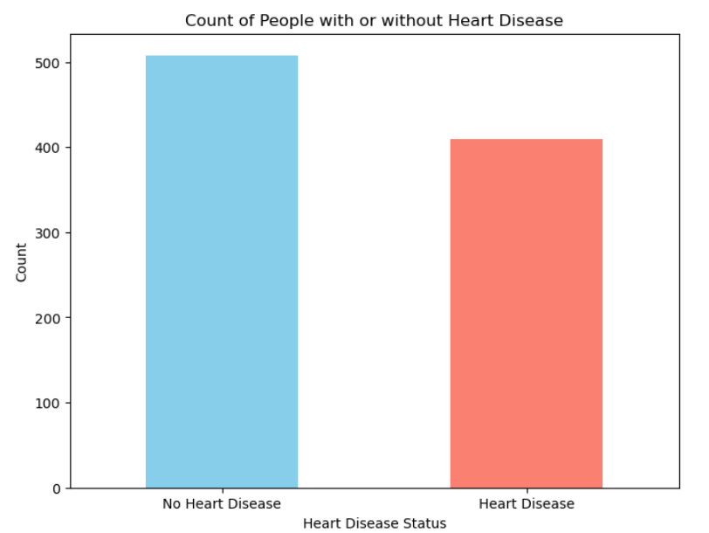

We have chosen bar plot to explain this.

A bar chart, often known as a bar graph, is a chart in which data groups are represented by rectangles. Rectangles' height and length correspond to the values they stand for. Plotting bar charts can be done vertically or horizontally. Comparisons between various groups are displayed using bar charts. The particular categories under comparison are shown on one axis of the chart, while the metrics that correspond to those categories are shown on the other.

The title is given as heart disease distribution. And a label for each bar in the bar graph is given as “No heart disease” and “Heart disease”. The color palette given is blue and salmon, where blue depicts no heart disease and orange depict heart disease. In the graph, we can understand that above 500 people don’t have heart disease and more than 300 people have heart disease.

**Heart disease present by gender**

The occurrence of heart disease can be influenced by various factors, including biological, behavioural, and socio-economic factors.

**1. Biological Factors:**

The **development** of heart disease can be influenced by **many** factors, including biological, **behavioral** and **socioeconomic** **factors.** Biological **features:  
Hormonal** Differences: **Estrogen** **is** a **drug** **that** **is** more **common** in **women** **and** **is** associated with cardioprotective effects. Before **physical** **weakness,** **most** women have a lower risk of heart disease **than** men of **the** **same** age. However, **the** **increased** **risk** after **menopause** **suggests** **that** **estrogen** **plays** **a** **role** **in** **preventing** **heart** **diseases.** **Some** **genetic** **changes** **may** **affect** the risk of **heart** **disease** in **men** **and** **women** **by** **affecting** cholesterol metabolism, blood pressure **control** and other heart **diseases.**

**2. Behavioural Factors:**

Lifestyle **choices:** **Behavioral** **habits** such as diet, physical activity, **smoking** and alcohol consumption **can** **affect** heart **disease.** Men and women **make** **different** lifestyle choices, **and** **differences** in **food** preferences, exercise and **smoking** **habits** **lead** to differences in heart disease **risk.** **pain.** Gender-specific stressors and coping mechanisms may **be** **differentially** **associated** **with** **cardiovascular** risk in **men** and **women.**

**3. Socio-Economic Factors:**

Access to **healthcare:** **Differences** in access to **healthcare,** preventive **screening,** and treatment options **may** affect **cardiovascular** **risk.** **Health** factors such as income, **education,** and **health** insurance **can** **affect** the likelihood of receiving timely **treatment** and managing cardiovascular **events.** **Regular** working **hours** **promote** the development of heart disease. Gender differences in **job** choices and **work** environments may **influence** **cardiovascular** **disease.**

**4. Risk Factor Profile:**

Risk **factors:** **Many** **heart** **disease** risk **factors,** **such** **as** **high** **blood** **pressure,** hypercholesterolemia, diabetes, **obesity** and **a** sedentary lifestyle, may **differ** between **mother** and **man.** For example, men **are** **more** **likely** to **get** heart disease at a younger age and **to** have higher **blood** **pressure** and **to** **smoke,** while women **are** **more** **likely** **to** **get** heart disease **at** **a** later **age** and have **more** diabetes and **obesity.** Factors: Certain risk factors, such as **pregnancy** complications (e.g., gestational diabetes, preeclampsia), **hormonal** **changes,** and autoimmune diseases (e.g., lupus), are specific to **women** and can **cause** heart disease.

**5. Awareness and Diagnosis:**

Gender **health** **care:** Historically, heart disease has been **considered** a **disease** **that** **occurs** predominantly **in** **men,** leading to **underrecognition** and underdiagnosis of heart disease in women. Gender bias in healthcare **can** **lead** **to** **delays** in diagnosis, inadequate risk assessment, and **poor** treatment **outcomes** for **women,** **leading** to disparities in **cardiovascular** **disease.**

The graph below shows the count of people who have or have not heart disease.

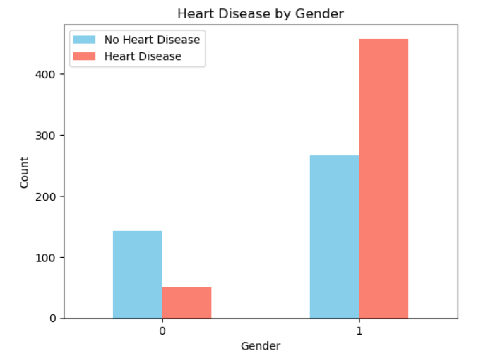

We have chosen bar plot to explain this. A bar plot or bar chart is a graph that represents the category of data with rectangular bars with lengths and heights that is proportional to the values which they represent. The bar plots can be plotted horizontally or vertically. A bar chart describes the comparisons between the discrete categories. One of the axes of the plot represents the specific categories being compared, while the other axis represents the measured values corresponding to those categories.

The title is given as heart disease by Gender. And labels for each bar in the bar graph is given as “No heart disease” and “Heart disease”. The color palette given is blue and salmon, which depicts “No heart disease” and “Heart disease”. 0 mentions Female and 1 depicts Male.

**Heatmap:**

**The** **death** **toll** **around** the world **is** **increasing** **day** **by** **day.** **This** **may** be **due** **to** the **increasing** **number** of **patients** with **heart** disease. **Considering** **the** **number** **of** **deaths** and **the** number of people **suffering** from heart disease, **the** **importance** **of** early diagnosis of heart **disease** **becomes** **evident.** **The** **most** **common** way **to** **predict** **heart** disease is **through** **a** doctor's examination or tests such as **an** **electrocardiogram,** **stress** **test,** and **heart** **MRI.** This hidden information is useful for making **good** decisions. **Computerized** **data** **and** advanced **data** mining techniques are used **to** **obtain** appropriate results. Neural **networks** **are** widely used **tools** **to** **predict** **heart** **disease.** **This** **article** **presents** **the** **prediction** **of** heart disease **using** **the** artificial neural network backpropagation **algorithm.**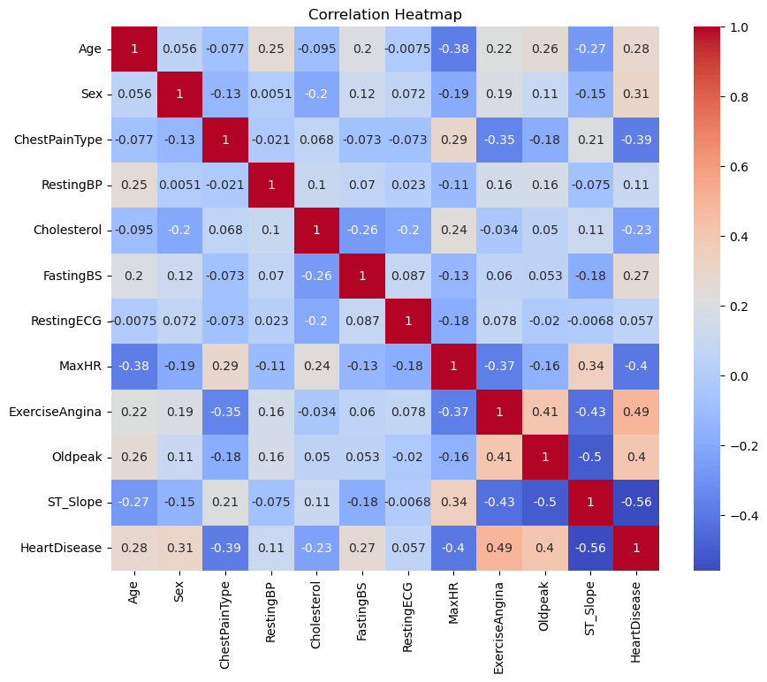

Twelve columns total—sex, age, ChestPainType, RestingBP, and so on—along with a target column that indicates whether or not the individual has heart disease. All of the other columns in the dataset will remain independent variables, with the exception of the target column, which will serve as our dependent variable.

**Scatter Plot of Maximum Heart Rate**

Adults typically have a heart rate between 60 and 100 beats per minute. A well-trained athlete, for instance, will have a heart rate that is almost exactly 40 beats per minute. Just check your heart rate to find out how much it is. Put your forefinger and index finger up against your neck's windpipe. Place two fingers on the wrist bone and muscle directly above the thumb's radial artery to feel your pulse there. Your heart rate per minute can be calculated by multiplying this value by four.

Remember that many factors can affect heart rate, including:  
Age  
Health and activity level  
Smoking  
heart disease, high blood pressure, cholesterol or diabetes  
**Temperature  
body position (such as standing or lying down)  
Mood**

For **intense** **exercise,** your heart rate should be between 64% and **76%** **of** your maximum heart **rate.** **bpm,  
76%** level: 170 **>** **Your** target heart rate **for** **physical** **exercise** should be between 77% and 93% of your maximum heart rate. To **calculate** this **row,** follow the formula used above, **changing** **64%** and **76%** to **77%** and **93%.** For example, for a 35-year-old person, the estimated **age** **of** maximum heart rate would be 220 **×** 35 years = 185 beats per minute (bpm). The 77% and 93% levels **are:  
â** 77% level: 185 x 0.77 = 142 bpm, **â** 93% level: 185 x 0.93 = 172 bpm  
This **is** **for** **ages** **35-** **Older,** **Heart** **rate** **during** physical activity **should** **be** between 142 and 172 **bpm.**

**Methods for Measuring MHR**There are numerous ways to figure out your maximal heart rate, however the most researched ones are as follows:   
• Fox formula: 220 - age is the most popular formula for both men and women.   
• For women alone, the Gulati formula is 206 - (0.88 × age).   
• For both men and women who are active, the HUNT calculation is 211 - (0.64 x age).   
• Tanaka formula: 208 - (0.7 × age) for both men and women over 40

**Age-Based MHR Formulas**

For a long time, 220 minus age was the formula used to determine maximal heart rate. Ultimately, specialists discovered that this model had a serious flaw in that it failed to account for the aging changes that the heart experiences. The heart's natural pacemaker, the sinoatrial cavity, is inhibited by aging, which is one explanation for this. This is not factored into the Fox formula. This difference is significant. In order to better anticipate women's peak heart rates by age, Martha Gulati and colleagues created a model especially for them. It was discovered that several of these models also had the highest heart rates of women. Obtaining a precise MHR is challenging unless you are in a testing environment and have access to the machine. So we did the next best thing: take a guess.

**Using The MHR Formula**

Example: The Tanaka Formula can be used to determine the maximum heart rate of a typical 45-year-old. Here's an example:   
208 minus (0.7 x 45) equals 177 beats per minute.âoe If you calculate the above and the result is the greatest amount of time your heart can beat in a minute. Based on your level of fitness, you can use this information to calculate how much work you should put in when exercising. You should work between 64% and 74% of your MHR if you are working less. Run between 80% and 91% of MHR.

**Estimating the maximum heart rate in individuals undergoing beta-adrenergic blockade therapy for coronary heart disease:**

Individuals with coronary heart disease (CHD) are commonly prescribed beta-adrenergic blocker (BB) therapy; hence, these individuals are frequently diagnosed while on this medication. However, because the current equation calculates maximum heart rate (HR (max); i.e., 220 − age) based on patients without heart disease or BD therapy, the evaluation of maximum voluntary elevation during exercise testing is frequently questioned. In order to predict HR (maximum) in CHD patients receiving BB treatment, an age-specific equation was developed and validated in this investigation.

**Understand Your Numbers: Age-Specific Maximum and Target Heart Rate**

**Heart rate goals for various age groups are displayed in this table. About 220 minus your age is your maximum heart rate. Approximately 50–70% of your maximum heart rate is the ideal heart rate during intensive exercise, while Approximately 70–85% of your maximum heart rate is the target heart rate during moderate exercise.**

*The figures are averages.

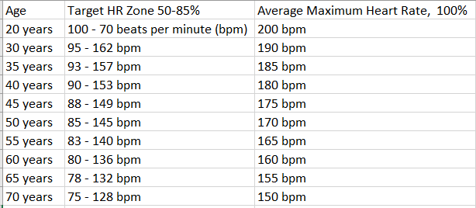

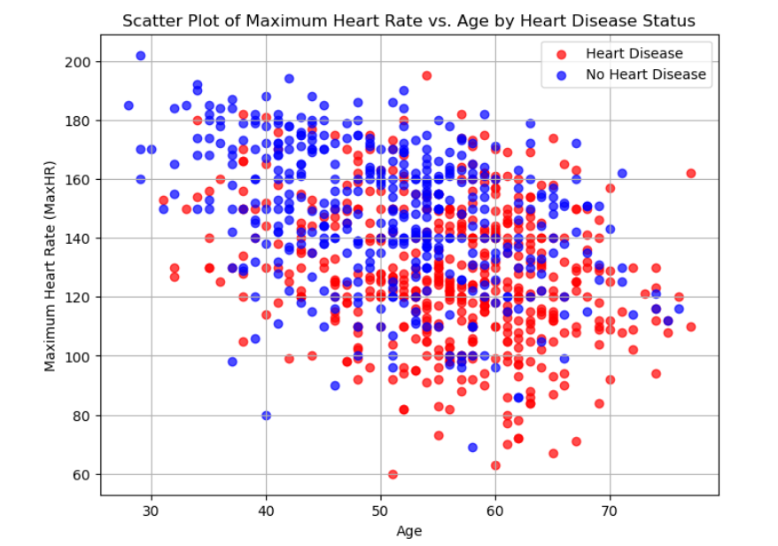

**Disease Presence by heart chest pain**

Angina  
Reduced blood supply to the heart is the cause of angina, a form of chest pain. One sign of coronary artery disease is angina. Pain or discomfort in the chest may feel like: **Burning  
Feeling  
Heart  
Tightness  
Improvement** in the **neck,** arms, neck, jaw, **shoulders** or **back.** **Angina** **pectoris** **includes:**

Dizziness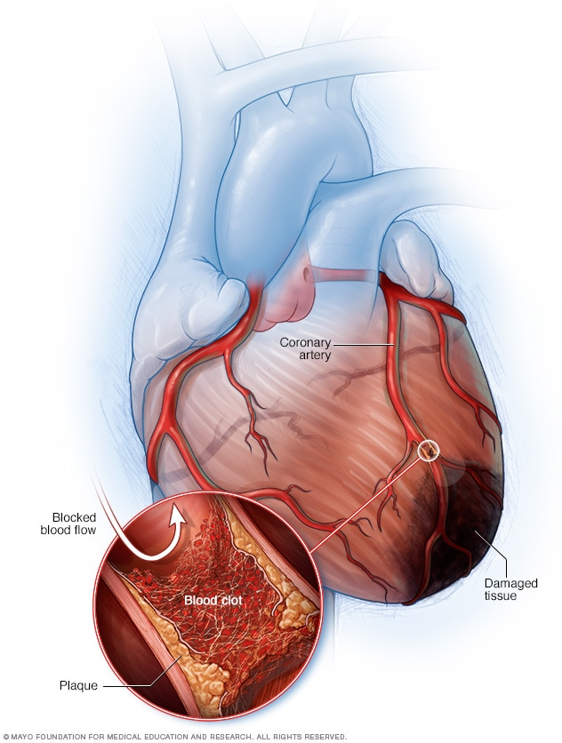

Nausea

Shortness of breath

Sweating

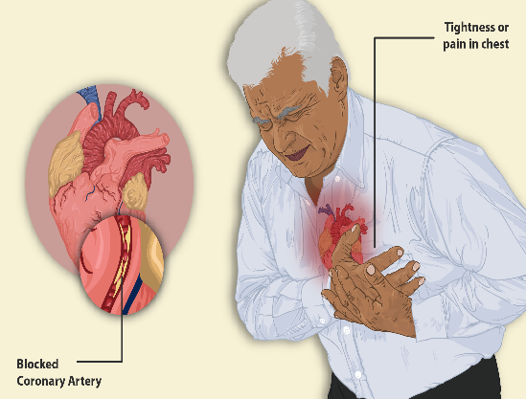 Conventional angina: Chest pain that: (1) causes discomfort or pain in the retrosternum; (2) is brought on by stress or exertion; and (3) is eased by rest or nitroglycerin (or both). Angina: When two of the three characteristics of classic angina are met, chest discomfort is diagnosed. To define angina pectoris, it might be referred to as normal angina pectoris.

**Predicting Heart Disease**

Since we try to predict heart disease based on the features in our dataset.

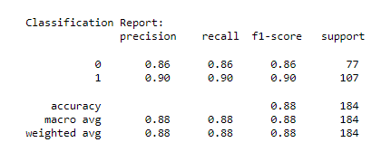

Since **we** **are** **dealing** **with** binary decisions, **we** **take** the maximum **outcome** **probability.** **The** **accuracy,** **precision,** **regression** **and** **F** **test** of the prediction **model** are **evaluated** **in** this step. **The** **maximum** is **determined** **by** the model with **sensitivity,** **return** and **F** **measurement.** **Accuracy** **testing** is used to **evaluate** the **accuracy** **or** precision of the MLC or **model** **prediction.** In mathematics, it is **derived** **from** equation.

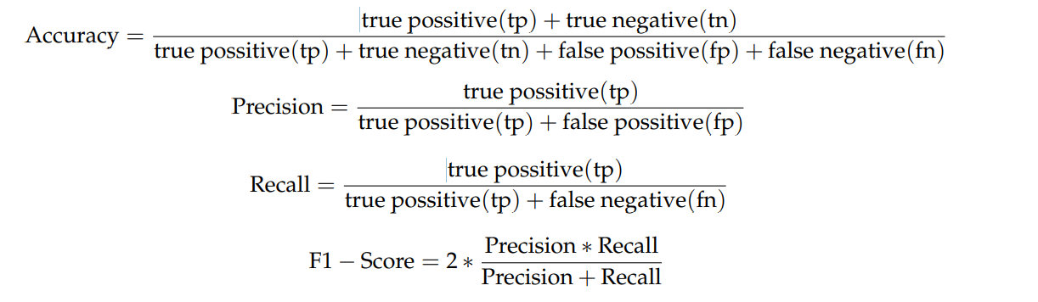

**Confusion Matrix** 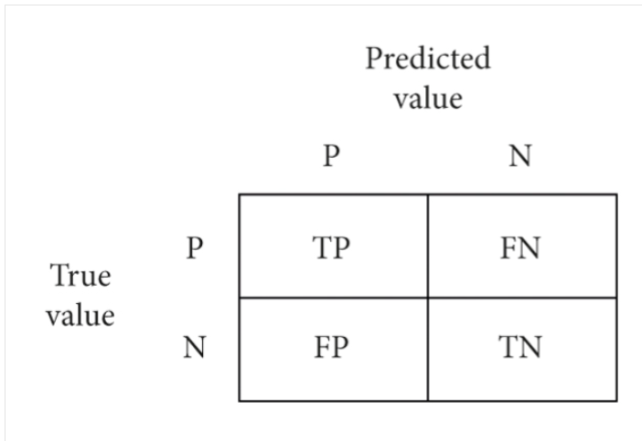

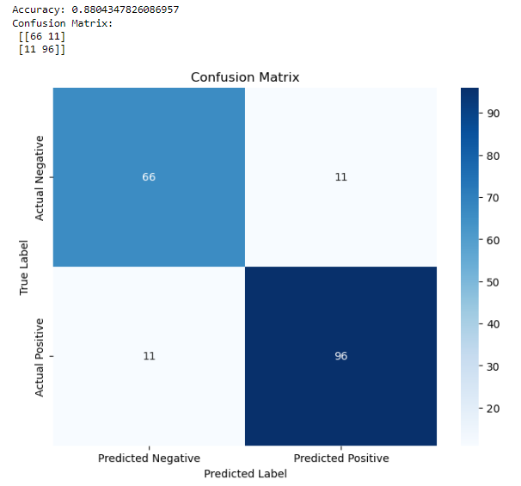

**Conclusion**

Heart **disease** is **a** major **concern** **in** **today's** **society.** It is difficult to manually determine the **difference** **between** heart disease based on **risk.** However, using **machine** **learning,** we **can** **instantly** predict whether **a** person **has** heart **disease.** **Thanks** to the **rapid** and accurate classification of heart **diseases,** doctors will **offer** **appropriate** treatment to patients and save their **lives.**

**References:**

1. K. Polaraju, D. Durga Prasad, “Prediction of Heart Disease using Multiple Linear Regression Model”, International Journal of Engineering Development and Research Development, ISSN:2321-9939, 2017.
2. Drożdż, K.; Nabrdalik, K.; Kwiendacz, H.; Hendel, M.; Olejarz, A.; Tomasik, A.; Bartman, W.; Nalepa, J.; Gumprecht, J.; Lip, G.Y.H. Risk factors for cardiovascular disease in patients with metabolic-associated fatty liver disease: A machine learning approach. Cardiovasc. Diabetol. 2022, 21, 240.
3. Marjia Sultana, Afrin Haider, “Heart Disease Prediction using WEKA tool and 10-Fold cross-validation”, The Institute of Electrical and Electronics Engineers, March 2017.
4. Dr.S.Seema Shedole, Kumari Deepika, “Predictive analytics to prevent and control chronic disease”, https://www.researchgate.net/punlication/316530782, January 2016.
5. Ashok Kumar Dwivedi, “Evaluate the performance of different machine learning techniques for prediction of heart disease using ten-fold cross-validation”, Springer, 17 September 2016.
6. Megha Shahi, R. Kaur Gurm, “Heart Disease Prediction System using Data Mining Techniques”, Orient J. Computer Science Technology, vol.6 2017, pp.457-466.
7. Mr. Chala Beyene, Prof. Pooja Kamat, “Survey on Prediction and Analysis of the Occurrence of Heart Disease Using Data Mining Techniques”, International Journal of Pure and Applied Mathematics, 2018.
8. R. Sharmila, S. Chellammal, “A conceptual method to enhance the prediction of heart diseases using the data techniques”, International Journal of Computer Science and Engineering, May 2018.
9. Jayami Patel, Prof. Tejal Upadhay, Dr. Samir Patel, “Heart disease Prediction using Machine Learning and Data mining Technique”, March 2017.
10. Purushottam, Prof. (Dr.) Kanak Saxena, Richa Sharma, “Efficient Heart Disease Prediction System”, 2016, pp.962-969.
11. K.Gomathi, Dr.D.Shanmuga Priyaa, “Multi Disease Prediction using Data Mining Techniques”, International Journal of System and Software Engineering, December 2016, pp.12-14.
12. Bo Jin, Chao Che, Zhen Liu, Shulong Zhang, Xiaomeng Yin, And Xiaopeng Wei, “Predicting the Risk of Heart Failure With EHR Sequential Data Modeling”, IEEE Access 2018.
13. Aakash Chauhan, Aditya Jain, Purushottam Sharma, Vikas Deep, “Heart Disease Prediction using Evolutionary Rule Learning”, “International Conference on "Computational Intelligence and Communication Technology” (CICT 2018).
14. Ashir Javeed, Shijie Zhou, Liao Yongjian, Iqbal Qasim, Adeeb Noor, Redhwan Nour4, Samad Wali And Abdul Basit, “An Intelligent Learning System based on Random Search Algorithm and Optimized Random Forest Model for Improved Heart Disease Detection”, IEEE Access 2017.
15. Senthilkumar Mohan, Chandrasegar Thirumalai, and Gautam Srivastava, “Effective Heart Disease Prediction Using Hybrid Machine Learning Techniques”, IEEE Access 2019.
16. K.Prasanna Lakshmi, Dr. C.R.K.Reddy, “Fast Rule-Based Heart Disease Prediction using Associative Classification Mining”, IEEE International Conference on Computer, Communication, and Control (IC4-2015)
17. Narin, A.; Isler, Y.; Ozer, M. Early prediction of Paroxysmal Atrial Fibrillation using frequency domain measures of heart rate variability. In Proceedings of the 2016 Medical Technologies National Congress (TIPTEKNO), Antalya, Turkey, 27–29 October 2016.
18. Shah, D.; Patel, S.; Bharti, S.K. Heart Disease Prediction using Machine Learning Techniques. SN Comput. Sci. 2020, 1, 345.
19. Alotaibi, F.S. Implementation of Machine Learning Model to Predict Heart Failure Disease. Int. J. Adv. Comput. Sci. Appl. 2019, 10, 261–268.

20. Hasan, N.; Bao, Y. Comparing different feature selection algorithms for cardiovascular disease prediction. Health Technol. 2020, 11, 49–62.